PROPERTY PERMISSION FORM
Affiliate Grants – Keep Oklahoma Beautiful, Inc.

By signing below, I/we understand that

____________________________________________________________________
Name of Organization

has applied for a Keep Oklahoma Beautiful 2026 Affiliate Grant to improve this

community area for the project of ____________________________________________________________________

in _____________________________________, Oklahoma.

Further, I/we are the legal owners of this area/structure and do
hereby give permission for it to be improved as described in the project application submitted to Keep Oklahoma Beautiful by said organization.

INFO/SIGNATURES

_______________________________________ ________________________________________
OWNER/BUSINESS SIGNATURE AFFILIATE SIGNATURE

_______________________________________ ________________________________________
GRANT PROJECT ADDRESS AFFILIATE MAILING ADDRESS

_______________________________________ ________________________________________
CITY ST ZIP CITY ST ZIP

_______________________________________ ________________________________________
OWNER/BUSINESS EMAIL AFFILIATE EMAIL

_______________________________________ ________________________________________
OWNER/BUSINESS PHONE AFFILIATE PHONE

_______________________________________ ________________________________________
SIGNATURE FROM CITY EMPLOYEE GRANT WRITER’S SIGNATURE
(If required by the city) (If different from Affiliate Contact)
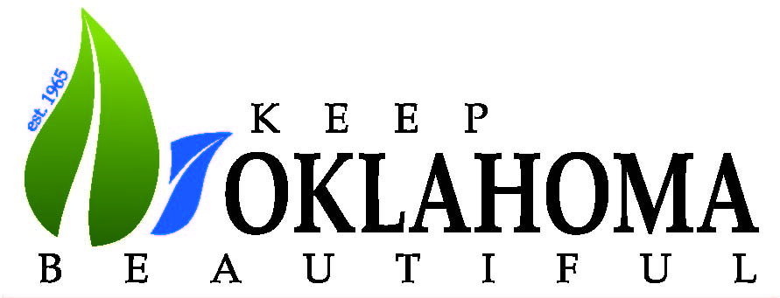

KEEP OKLAHOMA BEAUTIFUL, INC.
720 W Wilshire Blvd. Suite 114, Oklahoma City, OK 73116
405-286-9141 / affiliates@keepok.org / www.keepok.org

